11



Dear Customer

Check this link for updates ( and better pictures as printer is faulty)
http://www.tobin-stage.co.uk/2022/03/09/arduino-nano-midi-shield/

Thank you for the purchase of our Arduino Nano Midi Development Shield.

Please use a NANO 328P for best results as some cheap clones use inferior MCU’s the Arduino should be mounted to the board as shown. Incorrect fitment could damage the shield and/or the MCU

NOTE!! Fit the pin headers for the arduino before the MIDI sockets otherwise you can’t solder them

NOTE!! J3 can just be solder bridged but unplug the MIDI cable whilst programming.

Photo’s of early verison, V0.3.X has some minor alterations.

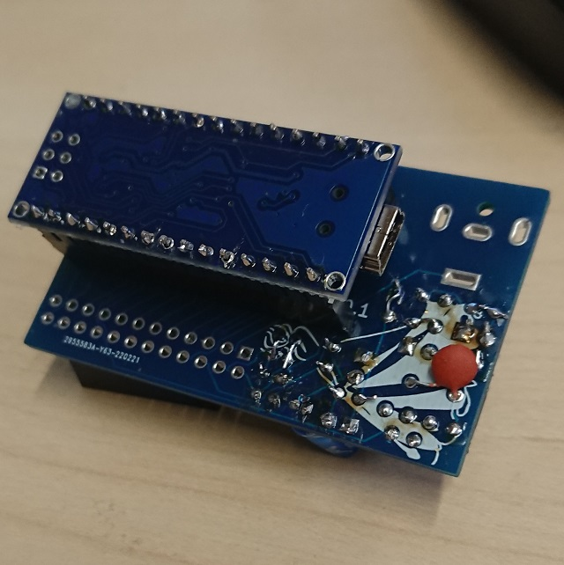

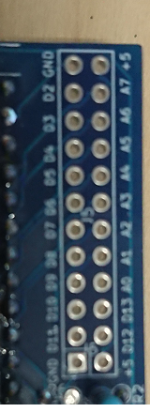

The interface connector is fitted as a pin socket array in the top corner, the pin designations can be seen in the diagram below.

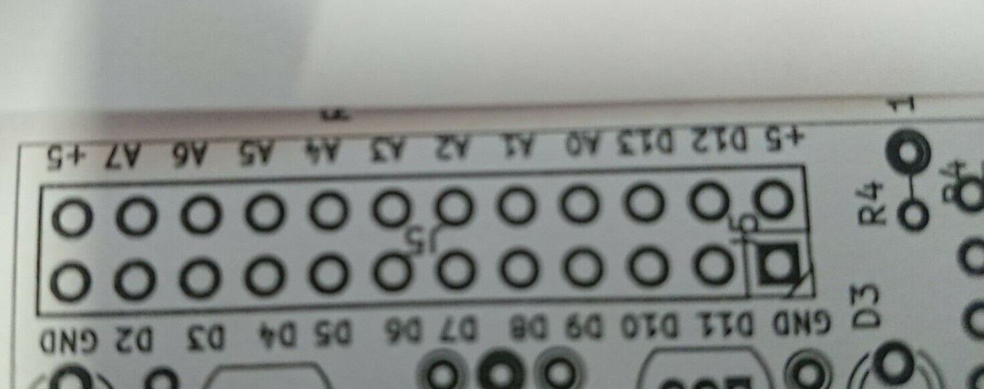

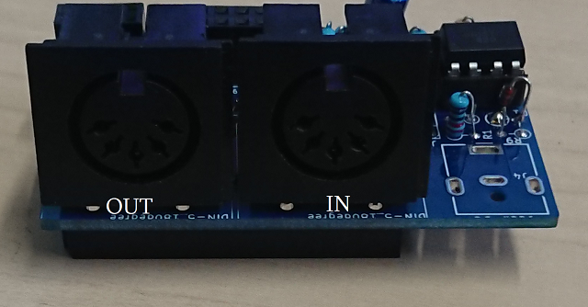

When uploading sketches please unplug the “MIDI IN” otherwise comms errors may occur

The following sketch can be used to test sending notes to your device on CH1.

https://docs.arduino.cc/built-in-examples/communication/Midi

The following sketch uses the additional midi.h library and is used to filter midi channels .

https://github.com/diyelectromusic/sdemp/tree/master/src/SDEMP/ArduinoMIDIFilter

5V DC can be applied to the jack connector on the PCB, A jack can be fitted if desired.

